|  |  |  |  |
| --- | --- | --- | --- |
| **Project Name: IW Express Logistics Management System** | | | |
| Project Manager | Rajasekar | Document Version | 1.1 |
| Technical Architect | Murugavel | Document Date | 20.01.2024 |
| Solution Consultants | Rajasekar/Mugilan/Senthil | Prepared on | 20.01.2024 |
| Prepared by | Rajasekar | Reviewed by | Domnic Regies |

**Distribution Information**

|  |  |  |  |
| --- | --- | --- | --- |
| **From: Tekclover Private Limited** | | | |
| **To : IW Express** | | Acceptance/Sign off | Sign-off date |
| IW Express | Mr. Ahmed Krez |  |  |

**Version Information**

|  |  |  |  |
| --- | --- | --- | --- |
| Ver No | Ver Date | Revised by | Description/File Name |
| 1.0 | 01.01.2024 | Rajasekar S | IW Express Logistics System – Business Blue Print – Airport Operations |
| 1.1 | 20.01.2024 | Rajasekar S | Changes suggested by Ahmed Krez |

Contents

**1.** **PURPOSE OF DOCUMENT** 3

**2.** **INTENDED AUDIENCE** 3

**3.** **Project Scope** 3

**4.** **Masters – Airport Operations** 4

**4.1** **Master – Hubs** 4

**4.2** **Master – Customer – Hubs Assignment** 4

**4.3** **Master – Service Providers** 4

**4.4** **Master – HS Codes** 4

**4.5** **Master – IATA** 4

**4.6** **Master – Drivers** 4

**4.7** **Master – Route** 4

**4.8** **Master – Vehicle** 5

**4.9** **Master – Driver- Vehicle – Route Assignment** 5

**4.10** **User Role** 5

**4.11** **User Profile** 5

**5.** **Business Process (To-Be) – Transactions** 6

**5.1** **Process Flow** 6

**5.2** **Process Steps:** 7

**5.3** **Reports** 11

# **PURPOSE OF DOCUMENT**

The primary purpose of this document is to capture the functional requirements of IW Express, Kuwait for the Logistics System Implementation to accommodate their business scenarios of Airport Operations for International Inbound Shipments. This document is prepared based on the business analysis conducted by Tekclover Pvt Ltd. It captures the business processes of Airport Operations which includes receiving Pre-alerts, Preparation of Manifest, generation of IW AWB Label, Preparation of Console, Preparation of CRR, Creation of Bayan/DO, Generation of Clearance invoices, Submission of Cost details to Finance for each Master AWB, Shipments transition to Hub and the detailed scope of the project deliverable.

The Blueprint and its associated appendices present a summarized perspective of all functional

Business processes that will be implemented. Blueprint document will serve - from this point forward the dual role of both official project scope as well as system acceptance criteria.

The body of this document describes the Scope, functional process flows to be implemented for IW Express. Generally, requirements can be met based on the standard business and system benchmarks accepted globally. However, certain key requirements are explicitly identified and summarized to highlight their importance to IW Express, to document the approach proposed to meet the requirement.

# **INTENDED AUDIENCE**

This document is intended for review by various user groups within IW Express with vested.

interests in this project. These groups should check the validity of business assumptions, the accuracy of the business functions, outputs, and the flow of processing logic described in the document. When

accepted, it will form the basis for the detailed design and development of the system.

This document is also meant for Tekclover Pvt Ltd., in the design, development, and testing phases of the system.

# **Project Scope**

New Logistics Management system will cover below process of Airport operations as a part of scope.

* Receiving Pre-Alert from Shippers
* Manifest Creation (Consolidation and Bonded)
* Console Creation
* Shipment Scan and receive through Mobile App
* Creation of Courier Consolidation Request
* Receive and Upload DO
* Receive and upload Bayan.
* Update Duty charges from Bayan to Shipments.
* Auto Updation of all Airport events
* Reports/Dashboard

# **Masters – Airport Operations**

The new Logistics system will have the below process for Airport Operations department.

## **Master – Hubs**

Airport Hub will be Maintained in this master. Details of the hub like hub type, status, location details, Contact details can be managed in this master.

## **Master – Customer – Hubs Assignment**

Each Customer can be assigned to one or more Hubs according to the requirements.

## **Master – Service Providers**

Service providers at Airport (Forklift, handling services) can be maintained in this master.

## **Master – HS Codes**

HS Code of the Products can be maintained in this master based on the Product group.

## **Master – IATA**

IATA Charges for the Clearance can be maintained in this master based on the Origin code.

## **Master – Drivers**

Drivers associated with IW Express can be maintained in this Master. Each Driver can be assigned with Unique ID.

## **Master – Route**

Route details of the serving Country/governorate/City can be defined in this master.

## **Master – Vehicle**

Vehicle details of IW Express are defined in the master. Detail like Vehicle Registration, Kms driven, last service date, status of the Vehicle can be defined in this master.

## **Master – Driver- Vehicle – Route Assignment**

IW Express Drivers are assigned to the respective route and Vehicle in this Master. This helps to pick the respective driver / Vehicles at the time of route determination.

## **User Role**

IW Express user’s role and access can be maintained in this master. Applications Screen’s with Create/Edit/Display/Delete access can be managed here.

## **User Profile**

Application’s users are created and managed in this master. User details like name, password, contact details, respective role are maintained in this master.

# **Business Process (To-Be) – Transactions**

IW Express Airport Operations handles International Inbound Shipments. Major responsibility of Airport team is to receive the shipments from Shipper, prepares required documents for Customs clearance, Submission of Goods for Customs Clearance, Generation of Customs Clearance invoice Forwarding the Cleared Shipments to the respective Hubs and submitting the cost details to Finance for each master AWB.

1. A screenshot of a computer flowchart

   Description automatically generated

## **Process Flow**

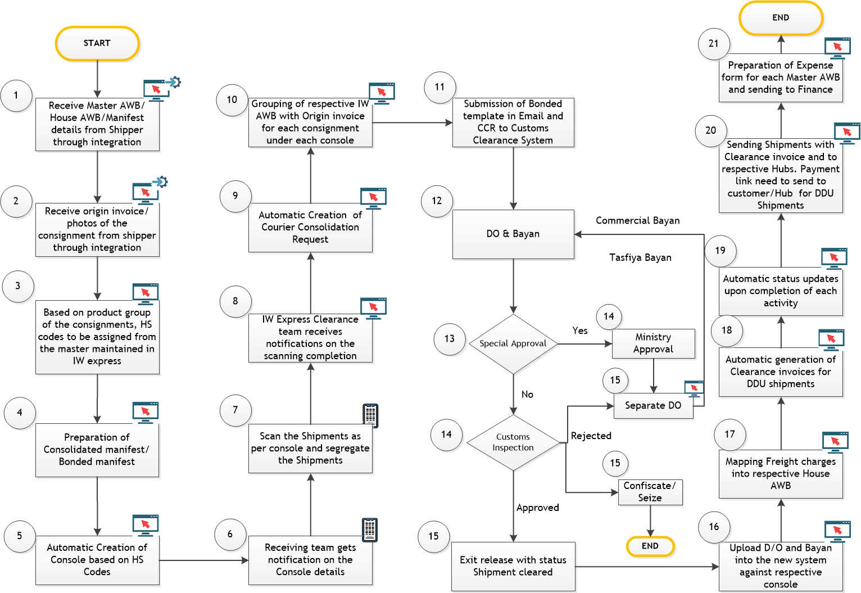

### **Process Steps:**

1. Shipper’s system will be integrated with IW Express new system (Logistics Management System) through B2B. Shippers will send Master Airway Bill / House Airway bill details to IW express through integration.
2. Shippers need to send Manifest, invoice and photos of the consignments to IW express LMS system through API or they can send in offline and the same can be uploaded into LMS as a single or bulk. If there are any changes in Manifest, Shipper sends updated Manifest and based on the updated manifest, details of Consol, bonded template, CCR template need to be changed automatically.
3. The system will determine HS codes of the consignments automatically based on HS Codes of each product group as per Origin manifest. HS Codes can be editable.
4. Consolidated Manifest/ Bonded Manifest need to be prepared automatically based on Consignment details shared by Customers. Customer should fill in the origin manifest with the below requirements so that it will automatically fill the consolidation manifest template, the bonded template, and the CCR template. Consolidation Manifest includes the fields which are sent by Customer in Origin Manifest.
5. HAWB
6. Origin
7. Origin Code
8. Shipper Name
9. Weight
10. PCS
11. Description
12. Consignee
13. Currency
14. Value
15. Customs KD = Convert to KD
16. IATA charges based on Schedule.

|  |  |  |
| --- | --- | --- |
| Origin | Origin Code | IATA KD |
| SZX/CAN | CN | 15 |
| IST | TR | 25 |
| JFK | US | 30 |
| LHR | GP | 25 |
| HKG | HK | 13 |
| DXB | AE | 6 |
| RUH | SA | 6 |
| BOM | IN | 5 |
| MCT | OM | 6 |

1. Console No
2. Airline No
3. Date

System Should calculate IATA charges from Consolidated Manifest based on Origin Code, currency, exchange rate etc.

Bonded Manifest template will have below fields.

1. HAWB
2. Current Date
3. Description
4. Weight
5. Pcs
6. Origin
7. Consignee
8. Shipper
9. MAWB number
10. Automatic Preparation of Console for grouping the Shipments based on HS Codes. HS Codes will be provided in Origin Manifest sent by Shipper. Console will make sure that shipments will not exceed 100 shipments or 5000 KD per console. (the Customs KD and IATA KD should not exceed 4900 KD). Also, HS Codes which require special approval will be segregated as a separate console. Option required to merge the HS codes which require special approval with another shipment that does not need special approval.
11. The prepared console will be pushed automatically to the receiving team’s mobile applications and the team will receive the notifications.
12. Receiving team will scan the shipments and segregate the shipments as per console and status of scan will be updated automatically.
13. The clearance team will receive the notifications in the system automatically once scanning is completed for a console.
14. Courier Consolidation request (CCR) will then be automatically prepared by the system for the scanning completed console. CCR preparation will take the data from the IW express manifest. CCR will have below details. To speed up the process, step 9 can be replaced by 6.
    * + Bill Number
      + H S Code (from H S Code sheet)
      + Goods Description
      + Country Of Origin
      + No Of Packages
      + Item Total Price
      + Quantity
      + Net Weight
      + Gross Weight
      + Is Exempted ( Yes if Total price < 100 KD, No if total price > 100)

If Is Exempted = No, below fields need to be added

* + - Consignee Name
    - Invoice Date
    - Invoice Type (Always FOP)
    - Currency
    - Invoice Supplier Name
    - Freight Currency (always KWD)
    - Freight Charges
    - Country Of Supply

1. Automatic Consolidation of IW Express AWB and Origin invoice for each shipment within a console by the system. Multiple Options of Printing required for the business team.

* Option 1: Print AWB and Invoice
* Option 2: Print AWB
* Option 3: Print Invoice

1. Downloading Bonded Manifest, CCR, IW Express AWB/Origin invoice from the LMS and Bonded Manifest will be sent to Bonded team (NAS/KU) as Email, and they will upload the same into Customs Clearance system manually. IW team will also send Email after checking.

IW team will submit CCR after checking.

1. Customs will inspect the shipments as per console for Clearance.
2. If the Shipments of a console require special approval, those will be moved to respective ministries and the status of the shipments will be updated as Special approval in the system and that will be handled in a Separate DO. Those shipments will then be processed again for Clearance after the approval is done.
3. For the other Shipments, Shipments will be processed for Clearance.
4. If Customs Clears the shipments DO will be sent by Customs and Bayan can be downloaded from Customs system in pdf format. If Customs reject the shipments, it will be Seized by customs or Return to Origin. The status of those will be updated in the Shipment by the Clarance team.
5. Upload Bayan/ DO into the Logistics Management system by selecting the Console.
6. Duty Charges Collected for each house AWB need to mapped automatically mapped from the Bayan (Feasibility study to be done)
7. Shipments will be categorized into DDU (Destination Duty Unpaid) and DDP (Destination Duty Paid) by the system by Shipper. Clearance invoices for DDU shipments will be generated automatically in the system. All DDU must apply 4 KD for all shipments) + 5% from shipments higher than 100 KD.
8. The status of each event will be updated in the system manually/automatically as per requirements. Admin User should have provision to revoke the status if required.
9. Cleared Shipments will then be moved to the respective hubs in the system along with Clearance invoices.
10. Clearance team will prepare the Cost details for each master AWB and send it to finance team. Expense details form will contain below details.
    * Shipper
    * No of Shipments
    * Date of Clearance
    * Invoice no for each Master AWB
    * Supplier Name
    * Description of Expenses
    * NAS Charges
    * Global Charges
    * Labor charges
    * Approval Charges
    * Handling and Forklift charges
    * Customs Duty 5% (to be copied automatically)
    * Stamp Charges
    * Total Amount

### **Reports**

* Consolidated Customs Clearance report by Month
* Separate DO tracking report
* Consignment status tracking report (as per IW team’s requirements)